FLOW & RESTORE YOGA & MEDITATION RETREAT
Part 1: Retreat Agreement
Please read this information carefully.
This Agreement is being made between Florentina Lam-Clark (“Teacher”), and you __________(“Client”).
We both legally agree to the following:
Program Description
You have enrolled in the Flow & Restore Yoga & Meditation Retreat. The inclusions of your package or program are as outlined on the website and below.
Price includes yoga and meditation teaching, 7 nights accommodation, including breakfast and vegetarian buffet dinner, transfer from airport to hotel and back to airport when booked on advised flight (otherwise own transportation needs to be arranged), a cacao ceremony, a desert trip for a Bedouin dinner.
Teacher Responsibilities
As your Teacher (Florentina Lam-Clark), my role is to:
- Be on time and prepared for the retreat sessions and classes.
- Offer support and accountability throughout the retreat.
- Answer any questions you may have as they arise.
- Ensure you have all the information you need to make the most of the retreat.
- Arrange your accommodation and inclusions as outlined on the website and above.
As the Client, it is your responsibility to:
- Show up on time at The Dahab Paradise Hotel for the commencement of the retreat.
- Advise with as much notice as possible if you anticipate any delays.
- Arrange and pay for your own flight to and from Sharm El Sheik as advised, transportation from Sharm El Sheik to Dahab Paradise is included when taking the advised flight. Ensure the timings of your transportation do not interfere or disrupt the timings of the retreat.
- Bring your own yoga mat
- Give 100% of your effort and fully commit to the retreat.
- Be open to new ideas, even if they challenge your existing beliefs.
- Promptly provide payment for the retreat according to payment dates set out
- Only provide advice to others when asked and respect the processes of other participants.
- Maintain an attitude of flexibility and fun!
Costs and Payment
Payment: Your investment in the retreat is as per the website. If you paid by deposit, the remainder is payable no later than 6 weeks before the start of the retreat. I will be in touch closer to the time with a reminder to make the final payment.
Authorisation and Receipt: You have been advised of bank account details to make your payment to, for which you will receive an electronic receipt.
Refunds: I have invested considerable time and effort in planning this retreat, so if you pay by deposit, your deposit is non-refundable. If you pay in full, up-front, our cancellation policy allows a 50% refund up to 6 weeks before the start of the retreat.
Any time after that you will remain fully responsible for the full cost of the retreat, and no refund will be provided.
However, at any point, you can give your spot to someone else. All requests for refunds or transfers must be received in writing to florentinalamclark@hotmail.com.
Due to the Covid-19 outbreak: should this situation arise again and prevent the retreat from taking place then all monies paid will be refunded.
Liability
In registering for this retreat you agree that Florentina Lam-Clark shall not be held liable for theft or damage to personal possessions; personal injuries or medical conditions that develop during or after the holiday; or any costs, cancellations or changes incurred as a result of fire, natural disaster, war or threat of war, industrial action, technical problems with transport, airport closure or any other events beyond our control. You take part in the programme offered at your own personal risk.
Changes
Florentina Lam-Clark, reserves the right to change the program schedule if necessary. Florentina Lam-Clark is not liable or responsible for any expenses, including but not limited to lodging, meals, and transportation incurred by delays or other uncontrollable issues outside of the program. In the event that we need to cancel because of unexpected circumstances all monies paid will be refunded in full.
Travel insurance
It is recommended that you purchase appropriate travel insurance.
Confidentiality
Please be assured that all information exchanged in preparation for, and during the retreat is in strict confidentiality. Florentina Lam-Clark is prohibited from disclosing protected confidential information to anyone else without reason to know such information, except as when required by law or upon written authorisation by you.
Personal Responsibility & Disclaimer
You acknowledge that you take full responsibility for your health and well-being during the retreat. All yoga sessions are undertaken at your own risk. It is your responsibility in any yoga session to progress at your own pace and listen to your body. If at any point you feel discomfort or strain, you will let the teacher know and rest. You will advise of any injuries, mental or physical health conditions (including pregnancy) and dietary requirements before you book.
Florentina Lam-Clark cannot be liable or responsible for any injury, medical or psychiatric condition, loss or damages, to person or property, resulting from the taking of a yoga session or coming on retreat. By signing this agreement you are consenting to this Disclaimer.
Other Important Terms
Termination: Either of us may terminate this Agreement with seventy-two (72) hours written notice to the other. E-mail notification is permissible and sufficient to the e-mail address as set forth at the end of this agreement. All payment and refund policy terms as written above in this agreement, and all of the terms of this Agreement, will still apply even after termination.
Governing Law: This agreement shall be construed according to the laws of the United Kingdom, and both parties shall comply with all ordinances, regulations and rules of the United Kingdom.
Dispute Resolution: It is hoped that should we ever have any differences, we are able to work them out through a phone conversation or e-mail correspondence. However, should a dispute ever arise between us, you agree now that the only remedy that is available to you, or that can be awarded to you, is full refund of your Payment. No award of consequential or of any other type of damages may be granted to you.
By signing this Agreement, we are acknowledging that we have read, understood, agree to and accept all of the terms in this Agreement. Your registration in the retreat is not confirmed until this signed document has been received, and payment has been made.
Client Signature: ____________________________________________
Name: ____ __________________________________
Date: _____________________________________________________
E-mail: ____________________________________________________

Teacher Signature: ___________________________________________
Name: Florentina Lam-Clark
Date: ______________________________________________________

Part 2: Travel Information
Our venue is The Dahab Paradise Hotel in Dahab, Egypt, and you can learn more about them here: https://www.dahabparadise.com/

Retreat Timeline
Our retreat begins on Wednesday 14th of October 2020 in time for dinner and ends on Wednesday 21st October after lunch. These are your arrival and departure dates.
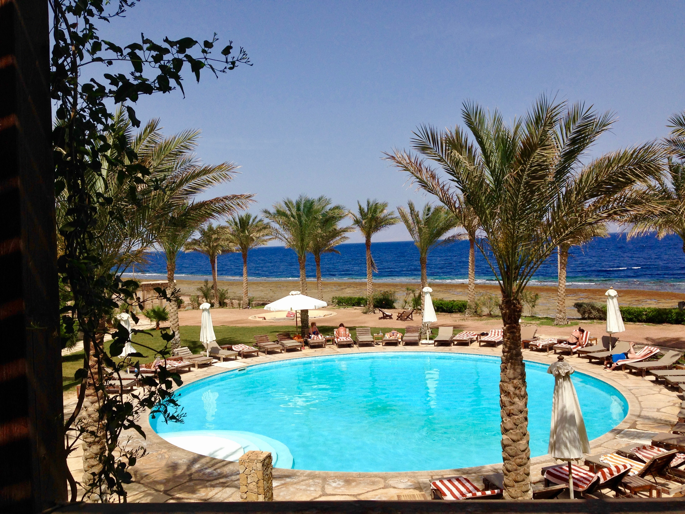

Getting There
From London the suggested flight is with Easyjet, Gatwick Airport 10.30am-17.00
(Prices are approximately £380.00 return, so it is advisable to book your flight sooner rather than later.
Transport pickup is arranged from Sharm El Sheik Airport to Dahab Paradise Hotel.

